`



**Hamilton’s Adventure Park**



**VISITORS GUIDE**

**Park Opening Times**

Hamilton’s Adventure Park is open from 9am to 9pm every day. We are closed on Christmas Day, Boxing Day, and New Year’s Day.

**Entry to the Park**

The Park Gates can be extremely busy. Standard Ticket Holders may queue for up to 30 minutes to enter the Park.

**Season Passes accepted**

Hamilton’s Adventure Park accepts Monthly and Annual season passes as well as entry bought at the park gates.

To help you plan your visit, these are our maximum overall queue and ride times for our main attractions throughout the year:



The Operational Research Society

 [www.theorsociety.com](http://www.theorsociety.com)

@TheORSociety or @ORinSchools

Facebook.com/TheORSociety

This leaflet has been designed by the education team at The OR Society for use as a maths teaching resource. For more free teaching resources or to request a maths career talk, visit The OR Website or email schools@theorsociety.com

**PARK GATES**

**CARNIVAL LAND**

**ANIMAL KINGDOM**

**CORKSCREW**

LOG FLUME

**WONDER WHEEL**

**ROLLER COASTER**

**THE HOLE**

Food / refreshments kiosks and toilet facilities are located throughout the Park

To help you make your way around the Park, our map includes the average time to travel directly between our main attractions

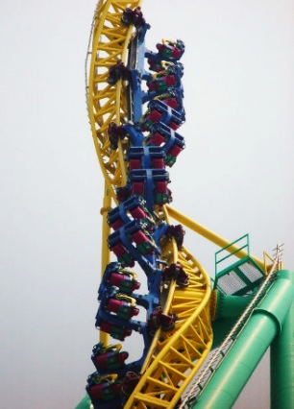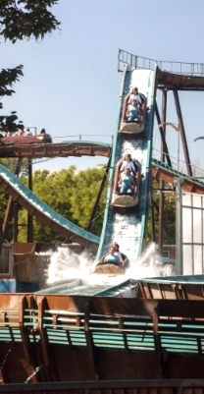



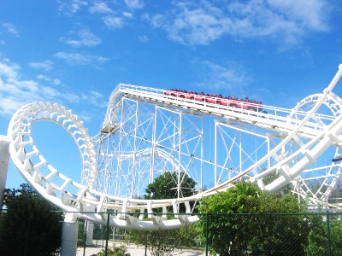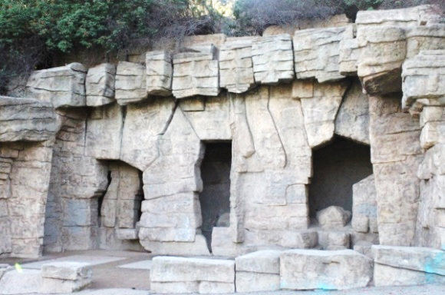

8m

12m

10m30s

3m

6m30s

6m30s

11m

14m

13m30s

9m

6m30s

9m30s

10m30s

